Note: This document is “view only”. Please create a copy of this document and save it to your drive.

**SOP - Moderating Free Facebook Groups- Systems Vault**

**PREREQUISITES**

[Ontraport](http://sarahnoked.com/ontraport)

[Teamwork PM](http://sarahnoked.com/teamwork)

[Master: SOP- Social Media Support- Systems Vault](https://docs.google.com/document/d/16_vB_Pr2GZCtCCyKX09VqTiRhNOREd0oP2VjFtXBeLY/edit?usp=sharing)

[Master: URLs (master links)](https://docs.google.com/spreadsheets/u/0/d/1mlQjpjNMlD4NJVtNFufaUVEE326vNw4TkKrwULAD43U/edit)

SN Template: Engaging New Members Directly in Free Community

SN Template (FB Chat/Group)- General Questions Canned Responses

[Group Leads](https://groupleads.net/)

[Group Leads Chrome Extension](https://chrome.google.com/webstore/detail/group-leads/fflgpaejocnobejfanekjilflogejjch)

SN Brand Voice

**PURPOSE**

To accept new members, manage and moderate our free Facebook groups and to ban and remove members when they are violating group rules.

**POLICY**

Our free groups are listed here [Master: URLs (master links)](https://docs.google.com/spreadsheets/u/0/d/1mlQjpjNMlD4NJVtNFufaUVEE326vNw4TkKrwULAD43U/edit) **\*SN Master: Social Media Accounts and Groups TAB*) FREE GROUPS ARE HIGHLIGHTED IN YELLOW**

Management of the free Facebook groups happen daily, Monday to Friday. (There is a recurring task in our [Teamwork PM](https://sarahnoked.teamwork.com/) to manage this)

When managing Sarah’s social media accounts, it is important to **log in with and use a Sarah Noked account**. If something requires follow up from Sarah, please send her a message via [Teamwork PM](https://sarahnoked.teamwork.com/) Chat in the Social Media channel. Please include the URL/link to the post to make it easy for Sarah to access the thread.

If you are accepting new members into the groups you must have the [Group Leads Chrome Extension](https://chrome.google.com/webstore/detail/group-leads/fflgpaejocnobejfanekjilflogejjch) installed. The licenses key and credentials are saved on the Group Leads password in Lastpass. Details of how to install this are listed in Step 1 below.

**All our free FB groups include answering questions upon request to join.**

Since we need to have admin approval for all posts, keep track of those who post promotions/job posts. If they keep on posting job posts and promotions, delete the post and remove the account from the group.

**POSTS:**  
In our free groups, all posts are first screened before posting.

Posts that violate the group rules include the following and are to be deleted immediately and not approved:

* Self promotion
* Being an asshole
* Job posting
* Soliciting and asking people to “DM me”
* Anything that feels offensive or inappropriate
* Spotlighting themselves as a coach

There is no need to follow up and alert people whose posts are not approved.

**COMMENTS:**

In our free groups, people can post comments freely.

Comments that violates the group rules include the following and are to be deleted immediately:

* Self promotion
* Being an asshole
* Job posting
* Soliciting and asking people to “DM me”
* Anything that feels offensive or inappropriate
* Spotlighting themselves as a coach

**RULE VIOLATIONS:**

If someone is violating our rules via comments, after 3 violations, the Social Media Manager will send a canned message to the person violating the rules and ban the member. On the other hand, the Social Media Support will send a canned message to the person violating the rules and request for a ban of a particular member via Teamwork Chat “SN Editorial & Social” channel .

You can find the template here: SN Template: Canned messages for people who violate rules

**PARTY**

Virtual Assistant

**PROPERTY**

Online Business Manager

**PROCESS**

Part 1: Accept new people to Free FB Groups

Part 2: Moderating the Free Facebook Groups

Part 3: Flagging Members in Free FB Groups

Part 4: Banning Members in Free FB Groups

**PROCEDURE**

**Part 1: Accept new people to Free FB Groups**

1. Install the [Group Leads Chrome Extension](https://chrome.google.com/webstore/detail/group-leads/fflgpaejocnobejfanekjilflogejjch).
2. Accept new members to each of our Free FB Groups [Master: URLs (master links)](https://docs.google.com/spreadsheets/u/0/d/1mlQjpjNMlD4NJVtNFufaUVEE326vNw4TkKrwULAD43U/edit) **\*SN Master: Social Media Accounts and Groups TAB\*** from Sarah’s profile
   1. Check Member Requests

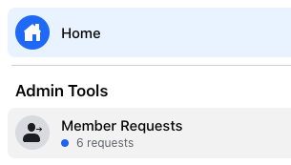

* 1. Screen new invite requests.
     1. Approve or decline request:
        1. TO APPROVE: Click approve.
           1. Accept requests from VAs, OBMs, people starting their online biz as a VA/OBM, etc.
           2. When members are approved, their email info will automatically populate to this spreadsheet: SN Master: COBM Leads Pulled from Group Leads and be added to our LEADMAGNET: Leads from Facebook Group campaign in [Ontraport](http://sarahnoked.com/ontraport)
        2. TO DECLINE: Click decline request, there is no need for follow up.
           1. Use your intuition:

Did this person just set up their FB account?- NO!

Does this person look spammy?- NO!

Is this person a Coach or someone looking to solicit or work with OBMs or not a VA OR OBM- NO.

If they didn’t answer ALL of the questions, then DECLINE!

**Part 2: Moderating the Free Facebook Groups**

1. Screen pending posts:
   1. If you see that there is nothing wrong with the post, **approve it.** This might include tech questions, course questions, wins, etc.
   2. If you think that the post might be exploited as a job opp or is spammy, etc. **DECLINE IT**. This might include “Looking for recommendations…”, “Any tech person here who knows how to do xyz?”, etc. Although the original poster might not mean it as a job opp, if we approve it people in the comments section might use it to promote themselves. *No need to send any follow up messages to the person who requested approval on these declined posts.*
   3. If it is a post that is considered as self-promotion, **DECLINE IT**. This includes posts that are straight up promoting themselves, or sneaky subtle posts where they post content that requires people to leave a comment to get a link to something because they want to “share the resource” when it was actually an opt in to their own mailing list, people posting their portfolio and résumé and asks for “feedback”, posts that has their brand logo, etc. *No need to send any follow up messages to the person who requested approval on these declined posts.*
2. On accepted pending posts “like” and if relevant (or make relevant) post a link to one of our free resources or blog posts. Or ask open ended questions about their business (NOT a question resulting in a YES/NO answer).
3. Engage Community
   1. React “Like” posts and comments
   2. Review comments on posts and post a link to one of our free resources or blog posts if and when possible
   3. When relevant, close comments on a post. (If it feels like enough has been said or if people are getting heated about something)

1. Encourage engagement by posting something interactive like a poll...
   1. Please keep our Brand Voice in mind when leaving comments.
      1. When relevant, encourage members to visit a relevant blog, opt-in or salespage
      2. When relevant, close comments on a post. (If it feels like enough has been said or if people are getting heated about something)

**Part 3: Flagging Members in Free FB Groups**

1. Remove comments that violate group rules (**for first time offenders**)
   1. Right click on the three dots next to the comment

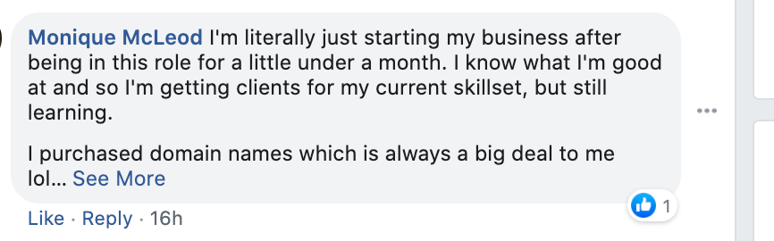

* 1. Click “Remove comment”
  2. Click on the rule the comment violated

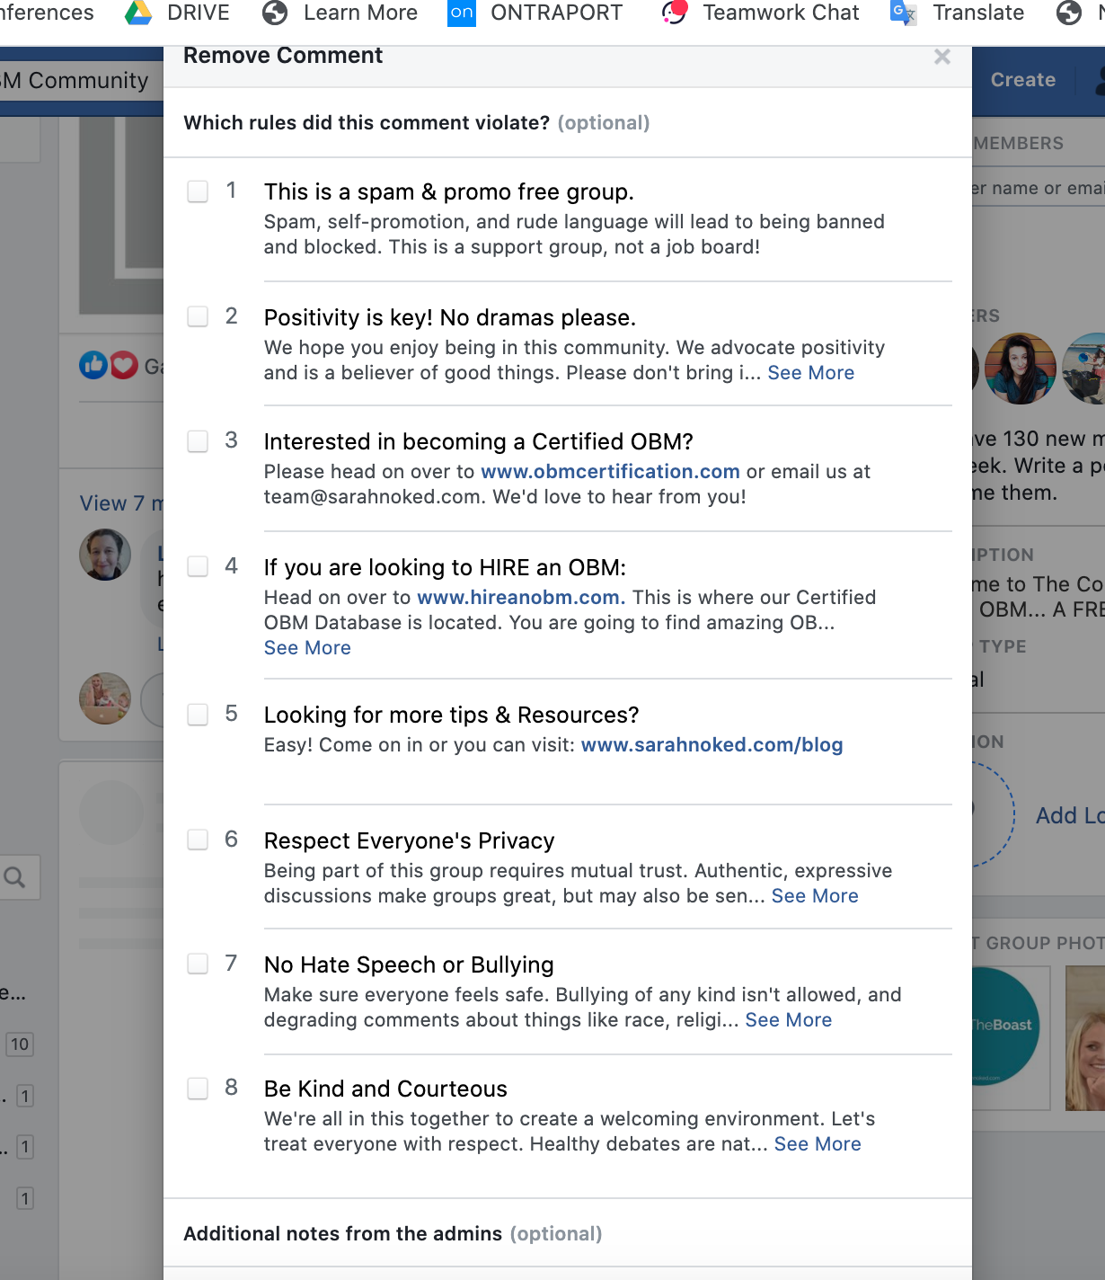

* 1. Post additional comment notes for the admins about why this comment is being removed and other relevant details
  2. Check the box to share our feedback “Share violated rules…” with the group member. Then click Remove.

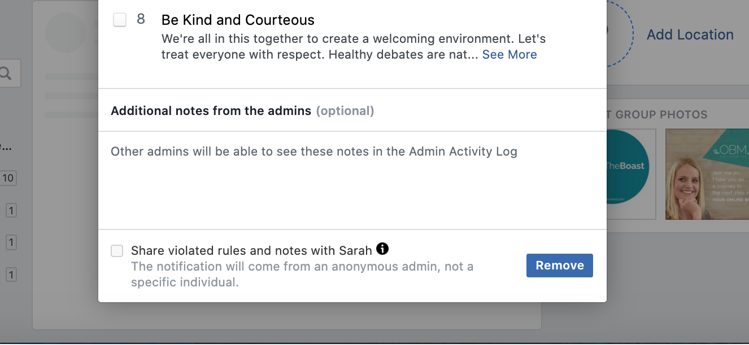

* 1. Check the “Activity Log” under “Admin Tools” to see if the person is a repeat offender. If the person is proceed to Part 4 of this SOP

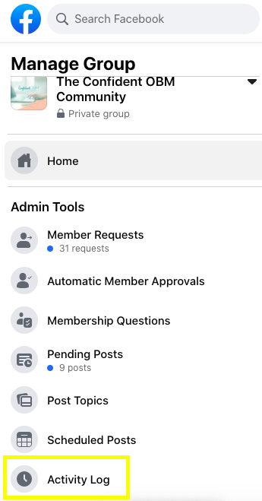

**Part 4: Banning Members in Free FB Groups**

See: SOP- Banning Clients - Sarah Noked OBM (not part of the Systems Vault)

**Created by:**

**Department:** Operations & Support

**Date:**

**Revised:**

**Revised by:**